Marks - 7
New column - Total_marks needed to be calculated
Comments and insights missing
library(readxl)
library(dplyr)
library(ggplot2)
library(cowplot)

grade = read_excel("C:/Users/Priya/Desktop/StudentsPerformance.xlsx")

View(grade)

head(grade)

tail(grade)

summary(grade)

nrow(grade)

str(grade)

print(grade)

grp_count = grade %>% count(group)
grp_count

grade %>% filter(is.na(group))
==
grade %>% filter(is.na(gender))

grade %>% filter(gender=='male' & group == 'group B')

grade %>% filter(group == 'group B' & math_score == 40)

new_grade = mutate(grade,average_score = round((math_score+reading_score+writing_score)/3))
new_grade$average_score
head(new_grade)

View(new_grade)

#Answer 1

agg_math_score = aggregate(new_grade$math_score, list(grade$group), FUN=mean)
colnames(agg_math_score) <- c('group','avg_math_score')
agg_math_score

agg_reading_score = aggregate(new_grade$reading_score, list(grade$group), FUN=mean)
colnames(agg_reading_score) <- c('group','avg_reading_score')
agg_reading_score

agg_writing_score = aggregate(new_grade$writing_score, list(grade$group), FUN=mean)
colnames(agg_writing_score) <- c('group','avg_writing_score')
agg_writing_score

agg_average_score = aggregate(new_grade$average_score, list(grade$group), FUN=mean)
colnames(agg_average_score) <- c('group','avg_student_performance')
agg_average_score

dev.off(dev.list()["RStudioGD"])

p1 = ggplot(agg_math_score, aes(x=group, y=avg_math_score, fill=group)) + geom_bar(stat="identity") +
labs(x="Groups", y="Average_Math_Score")
p1

p2 = ggplot(agg_reading_score, aes(x=group, y=avg_reading_score,fill=group)) + geom_bar(stat="identity") +
labs(x="Groups", y="Average_Reading_Score")
p2

p3 = ggplot(agg_writing_score, aes(x=group, y=avg_writing_score,fill=group)) + geom_bar(stat="identity") +
labs(x="Groups", y="Average_Writing_Score")
p3

p4 = ggplot(agg_average_score, aes(x=group, y=avg_student_performance,fill=group)) + geom_bar(stat="identity") +
labs(x="Groups", y="Average_Student_Performance")
p4

plot_grid(p1,p2,p3,p4,labels="AUTO")
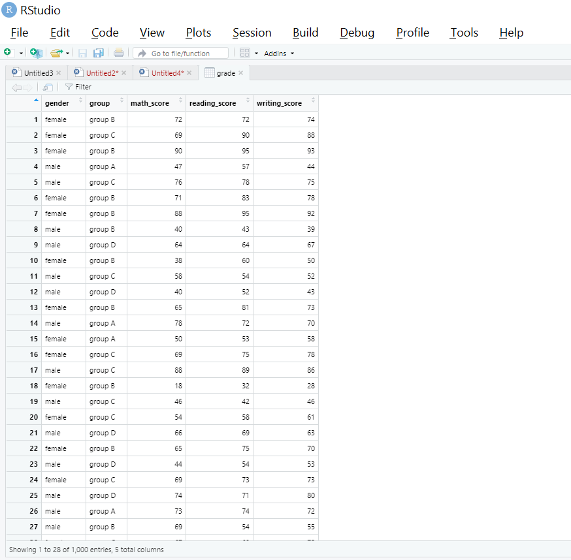
#Answer 2

grp2_avg = grade %>% group_by(group,gender) %>%
summarise(avg_math = mean(math_score))
grp2_avg

ggplot(grp2_avg,(aes(x=group,y=avg_math,fill=gender))) +
geom_bar(stat = "identity",position = "dodge")

#Answer 3

total_grade = mutate(grade,total_score = (math_score+reading_score+writing_score))
total_grade$total_score
head(total_grade)

grp3_total = total_grade %>% group_by(group,gender) %>%
summarise(sum_total = sum(total_score))
grp3_total

ggplot(grp3_total,(aes(x=group,y=sum_total,fill=gender))) +
geom_bar(stat = "identity",position = "dodge")

total_box=ggplot(total_grade, mapping=aes(x=group, y=total_score))+geom_boxplot()
total_box

total_box=ggplot(total_grade, mapping=aes(x=group, y=total_score, fill=gender))+geom_boxplot()
total_box
